
Programming For Artificial Intelligence (Lab)
Assignment - 10
Name:
Ali Maqsood.
Roll no:
SU92-BSAIM-F23-050.
Department:
Software Engineering Department.
Program:
Artificial Intelligence.
Section:
BSAI-4A
Question # 1:
Create a chatbot web application using Flask for backend and HTML/CSS for the frontend

bot.py:
from nltk.chat.util import Chat, reflections
pairs = [
[r"(?i).*hello.*|.*hi.*|.*hey.*",
["Hello! I'm your Study Planner Bot. How can I help you improve your productivity today?",
"Hi there! Ready to boost your studies? Ask me for a study plan, motivation, or focus tips.",
"Hey! I'm here to assist you with creating a productive study schedule."]],

[r"(?i).*study plan.*|.*plan for today.*|.*schedule.*",
["Here’s a detailed study plan for today:\n"
"9–11 AM: Focus on main subjects using the Pomodoro technique.\n"
"11–11:15 AM: Short break, hydrate, stretch.\n"
"11:15–1 PM: Practice exercises or assignments.\n"
"1–2 PM: Lunch break.\n"
"2–4 PM: Review lessons and summarize notes.\n"
"4–5 PM: Plan tomorrow’s tasks and review progress.",
"Today's study schedule:\n"
"9–10:30 AM: Core subject study\n"
"10:30–10:45 AM: Break\n"
"10:45–12 PM: Practice problems\n"
"12–1 PM: Review notes\n"
"1–2 PM: Lunch\n"
"2–4 PM: Secondary subjects or projects\n"
"4–5 PM: Organize tasks for tomorrow"]],

[r"(?i).*motivation.*|.*encourage.*|.*inspire.*",
["Remember: Consistency beats intensity. Keep moving forward, even in small steps!",
"You are capable of amazing things. Start now, momentum will follow.",
"Every study session counts. Take small actions and celebrate progress."]],

[r"(?i).*focus.*|.*concentration.*|.*avoid distractions.*",
["To improve focus: try the Pomodoro technique, remove distractions, and take 5-min breaks.",
"Focus tip: study in short intervals of 25–30 minutes and avoid multitasking.",
"Eliminate distractions: silence notifications, keep your desk clean, and stay hydrated."]],

[r"(?i).*break.*|.*relax.*|.*rest.*",
["Take a 10-minute break: stretch, drink water, and relax your eyes.",
"Break tip: Walk around, grab a snack, and reset your mind before the next study session.",
"Short breaks help maintain concentration. Try a quick meditation or breathing exercise."]],

[r"(?i).*tasks.*|.*todo.*|.*assignments.*",
["List your tasks clearly and prioritize the most important ones first.",
"Divide large assignments into smaller steps and schedule them across the day.",
"Track your tasks and mark them complete. This helps stay motivated."]],

[r"(?i).*sentiment.*|.*mood.*",
["You can tell me how you feel, and I can suggest motivation or relaxation tips."]],

[r"(?i).*bye.*|.*goodbye.*|.*see you.*",
["Goodbye! Keep studying smartly and stay productive.",
"See you later! Don’t forget to follow your study plan.",
"Take care! Remember to take breaks and stay consistent."]]
]
chatbot=Chat(pairs, reflections)

app.py:
from flask import Flask,render_template,request
from bot import chatbot

app = Flask(__name__)
@app.route("/")
def home():
return render_template("index.html")

@app.route("/chat",methods=["POST"])
def chat_route():
user_input=request.json.get("message")
response=chatbot.respond(user_input)
if not response:
response="I'm not sure how to respond to that. Try asking for a study plan, motivation, or focus tips."
return response
if __name__ == "__main__":
app.run(debug=True)
Output:
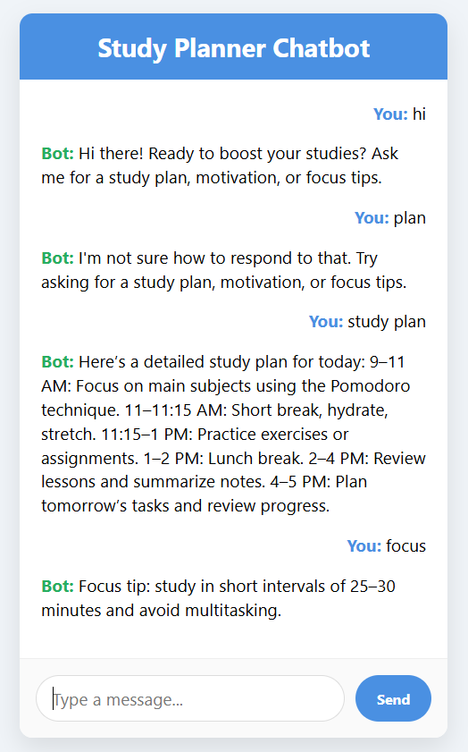

Documentation:
The Study Planner Chatbot is a web app that helps students plan their studies, stay motivated, focus better, and manage tasks. It is built using Python and Flask, and the chatbot uses NLTK with set patterns to answer questions. The chat interface is made with HTML, CSS, and JavaScript for a smooth, interactive experience. (The HTML, CSS, and JS were written with help from ChatGPT.)

